THE BOARD OF TRUSTEES
OF THE VILLAGE OF ROCA
MINUTES OF MEETING

DATE: January 13, 2025

TIME: 7:00 p.m.

LOCATION: Roca Community Center
15545 B St
Roca NE 68430

MEMBERS PRESENT AND OPEN MEETING ACT NOTIFICATION
Board member(s) present: Shawn Hemenway, Zack Goering, Steve Ossowski, Ralph Anderson. Chairman Chris Ibsen convened the meeting at 7:00 pm in compliance with the Public Meeting Requirements. Notice of the meeting was published in The Voice. Notification was given to the public of the open meetings law and notification to its location for public view.

APPROVAL OF MEETING MINUTES
Ossowski moved, seconded by Anderson to approve the minutes from December 9, 2024.Voting aye: Ibsen, Hemenway, Goering, Ossowski, Anderson. Motion carried.

APPROVAL OF TREASURER’S REPORT, RECEIPTS & DISBURSEMENTS
Goering moved, seconded by Hemenway, to approve the treasurer’s report and disbursements as follows:
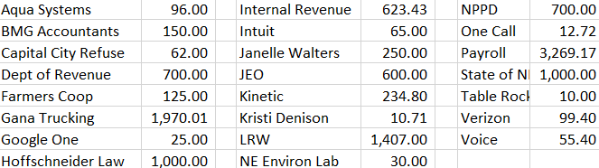
Voting aye: Ibsen, Goering, Ossowski, Anderson, Hemenway. Motion carried.

MEETINGS WITH ASSOCIATIONS
Cemetery- none
Planning Commission/Bldg.-none
Park/Roads – gravel applied to Vine Street between C & D St.
Water/Sewer –70% JEO Water/Sewer study. SCADA system bid

ADJOURNMENT
Hemenway moved, seconded by Anderson to adjourn the meeting at 8:04 pm. Voting aye: Hemenway, Goering, Ibsen, Ossowski, Anderson. Motion carried.

Respectfully submitted,
Kristi Denison, Clerk/Treasurer
Village of Roca

