THE BOARD OF TRUSTEES
OF THE VILLAGE OF ROCA
MINUTES OF MEETING

DATE: February 10, 2025

TIME: 7:00 p.m.

LOCATION: Roca Community Center
15545 B St
Roca NE 68430

MEMBERS PRESENT AND OPEN MEETING ACT NOTIFICATION
Board member(s) present: Shawn Hemenway, Zack Goering, Steve Ossowski, Ralph Anderson. Chairman Chris Ibsen convened the meeting at 7:00 pm in compliance with the Public Meeting Requirements. Notice of the meeting was published in The Voice. Notification was given to the public of the open meetings law and notification to its location for public view.

APPROVAL OF MEETING MINUTES
Goering moved, seconded by Ossowski to approve the minutes from January 13, 2025.Voting aye: Ibsen, Hemenway, Goering, Ossowski, Anderson. Motion carried.

APPROVAL OF TREASURER’S REPORT, RECEIPTS & DISBURSEMENTS
Anderson moved, seconded by Ossowski, to approve the treasurer’s report and disbursements as follows:
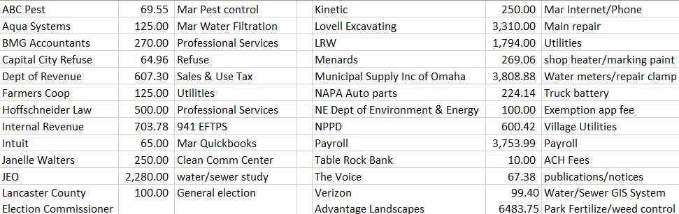
Voting aye: Ibsen, Goering, Ossowski, Anderson, Hemenway. Motion carried.

100% JEO WATER STUDY
Aaron Beauclair presented the 100% Water Study.

INVICTUS STRATEGIES
Jacob Stroh presented a bond portfolio analysis and discussed wealth management for the village.

GREEN COMMERCIAL REZONING APPROVAL
Motion to refile rezoning on A and Locust. Goering moved, seconded by Ossowski to refile zoning from residential to commercial. Voting aye: Anderson, Hemenway, Goering, Ossowski. Motion carried.

ADVANTAGE LANSCAPES
Anderson moved, seconded by Hemenway to approve the quote from Advantage Landscapes, Voting aye: Anderson, Hemenway, Goering, Ossowski. Motion carried.

AUDIT WAIVER
The request to waive the 2024 audit was approved.

MEETINGS WITH ASSOCIATIONS
Cemetery - Hemenway moved, seconded by Goering to approve the quote from Spencer Mowing. Voting aye: Anderson, Hemenway, Goering, Ossowski. Motion carried.
Planning Commission/Bldg.- Planning commission recommended rezoning Shea property from AG to residential
Park/Roads – Mower Trade-in, Norris Soccer contract, T-ball registration, Pavers quotes for roads presented
Water/Sewer –Church will be billed same as other entities, Meter installations, SCADA system bid presented

ADJOURNMENT
Goering moved, seconded by Hemenway to adjourn the meeting at 10:04 pm. Voting aye: Hemenway, Goering, Ibsen, Ossowski, Anderson. Motion carried.

Respectfully submitted,
Kristi Denison, Clerk/Treasurer
Village of Roca

