THE BOARD OF TRUSTEES

OF THE VILLAGE OF ROCA

MINUTES OF MEETING

DATE: April 14, 2025

TIME: 7:00 p.m.

LOCATION: Roca Community Center

15545 B St

Roca NE 68430

MEMBERS PRESENT AND OPEN MEETING ACT NOTIFICATION

Board member(s) present: Shawn Hemenway, Zack Goering, Steve Ossowski, Ralph Anderson. Chairman Chris Ibsen convened the meeting at 7:00 pm in compliance with the Public Meeting Requirements. Notice of the meeting was published in The Voice. Notification was given to the public of the open meetings law and notification to its location for public view.

APPROVAL OF MEETING MINUTES

Hemenway moved, seconded by Anderson to approve the minutes from March 10, 2025.Voting aye: Ibsen, Hemenway, Goering, Ossowski, Anderson. Motion carried.

APPROVAL OF TREASURER’S REPORT, RECEIPTS & DISBURSEMENTS

Ossowski moved, seconded by Hemenway, to approve the treasurer’s report and disbursements as follows:

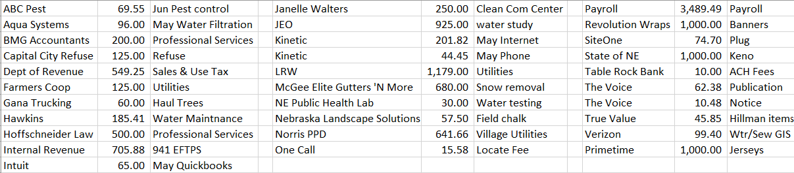

Voting aye: Ibsen, Goering, Ossowski, Anderson, Hemenway. Motion carried.

HYDRO OPTIMIZATION & AUTOMATION SOLUTIONS

Curtis Klein presented on the SCADA system. Motion to approve control system upgrade with cloud hosting for $34,573 with up to $2,000 a year for cloud hosting and a Verizon subscription, amount to be determined. Hemenway moved, seconded by Ossowski to approve HOA system and quote. Voting Aye: Ibsen, Ossowski, Anderson, Hemenway. Goering abstained. Motion carried.

MEETINGS WITH ASSOCIATIONS

Cemetery - none.

Planning Commission/Bldg.- none

Park/Roads – Culvert plugged to be looked at. Discussions were had on properties that have junk vehicles, tall weeds, concrete, iron pile, etc. Allo row agreement discussed.

Water/Sewer – delinquent accounts. Discussion on water ordinance and meters.

ADJOURNMENT

Ossowski moved, seconded by Hemenway to adjourn the meeting at 8:22 pm. Voting aye: Hemenway, Goering, Ibsen, Ossowski, Anderson. Motion carried.

Respectfully submitted,

Kristi Denison, Clerk/Treasurer

Village of Roca